STEPS  **TO START AND WORK IN A KAFKA TOPIC**

**1.STARTING ZOOKEEPER SERVER**

.\bin\windows\zookeeper-server-start.bat .\config\zookeeper.properties

**2.Starting kafka server**

.\bin\windows\kafka-server-start.bat .\config\server.properties

**3.Create a topic**

.\bin\windows\kafka-topics.bat --create --topic quickstart-events --bootstrap-server localhost:9092

**4.Describe the topic**

.\bin\windows\kafka-topics.bat --describe --topic quickstart-events --bootstrap-server localhost:9092

**5.Write to topic**

.\bin\windows\kafka-console-producer.bat --topic quickstart-events --bootstrap-server localhost:9092

**6.Read from the topic**

.\bin\windows\kafka-console-consumer.bat --topic quickstart-events --from-beginning --bootstrap-server localhost:9092

Make user and order repo

Creating the order service class

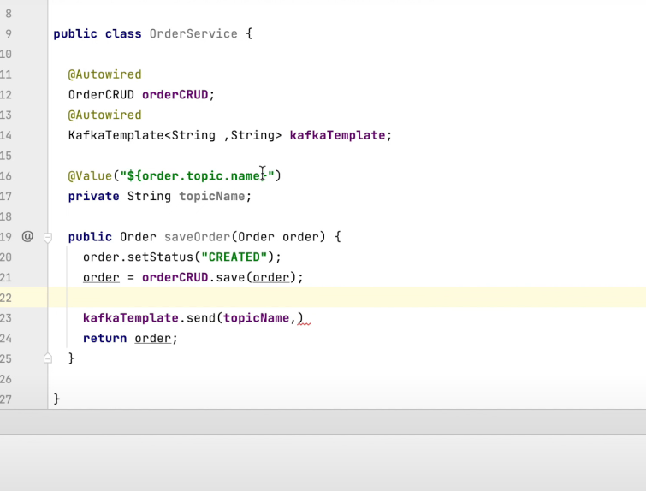

Now we have an object mapper used as shown above

Making the ordercontroller

Creating the usercontroller

Nowmake a consumer service

NOW WE HAVE ANOTHER PROJECT CREATED FROM  **SPRING INITIALIZER**

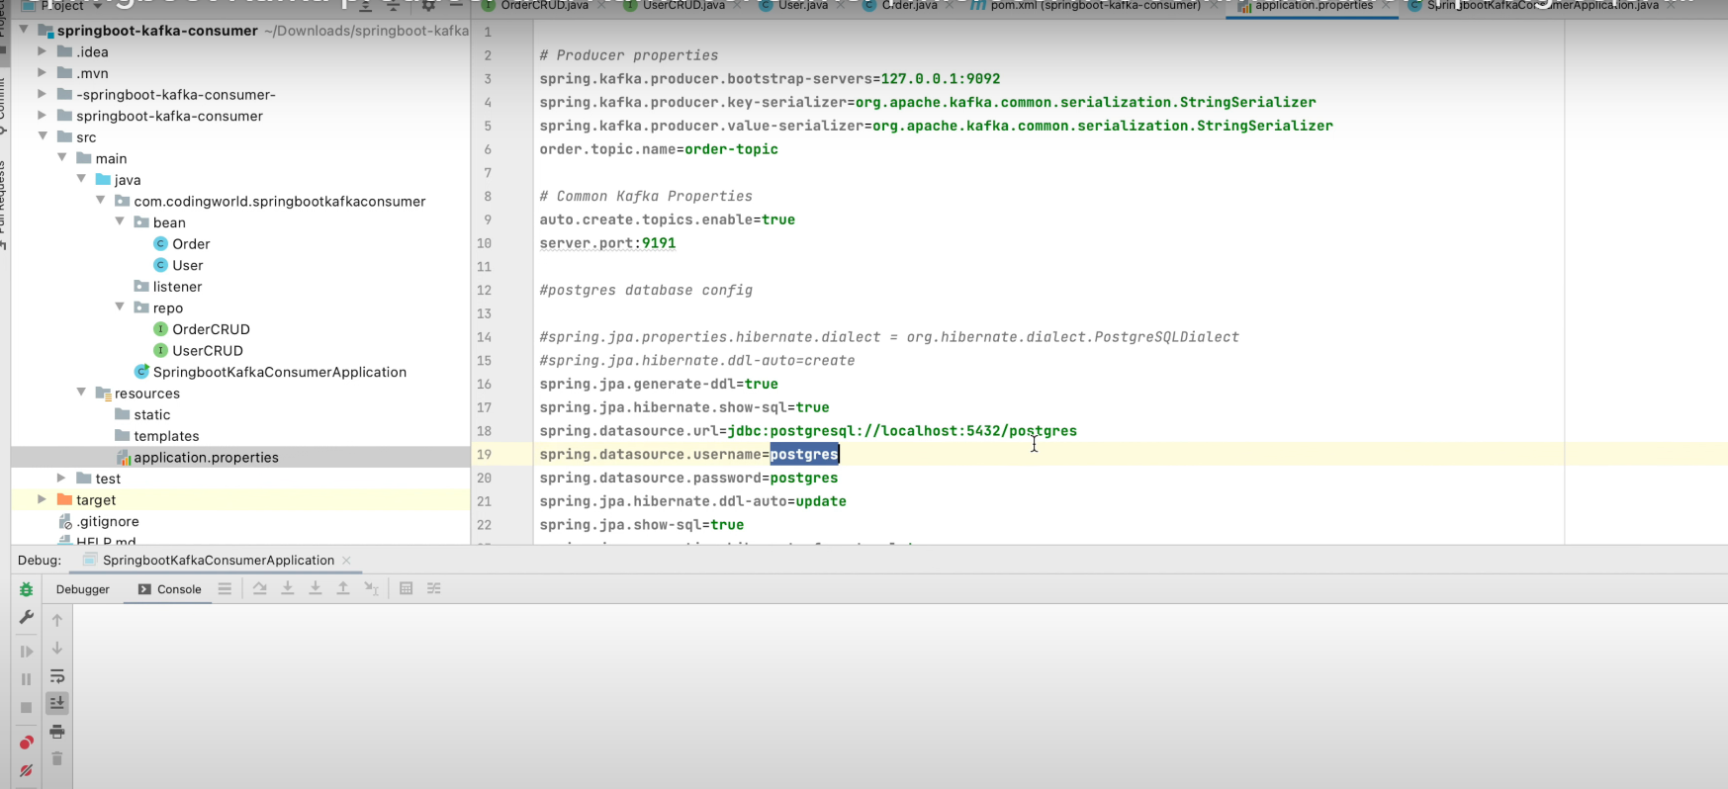**THE CONSUMER SERVICE**

In consumer service the application.properties will have the same configurations as in previous and also we will

Now we will make a listener in our consumer service

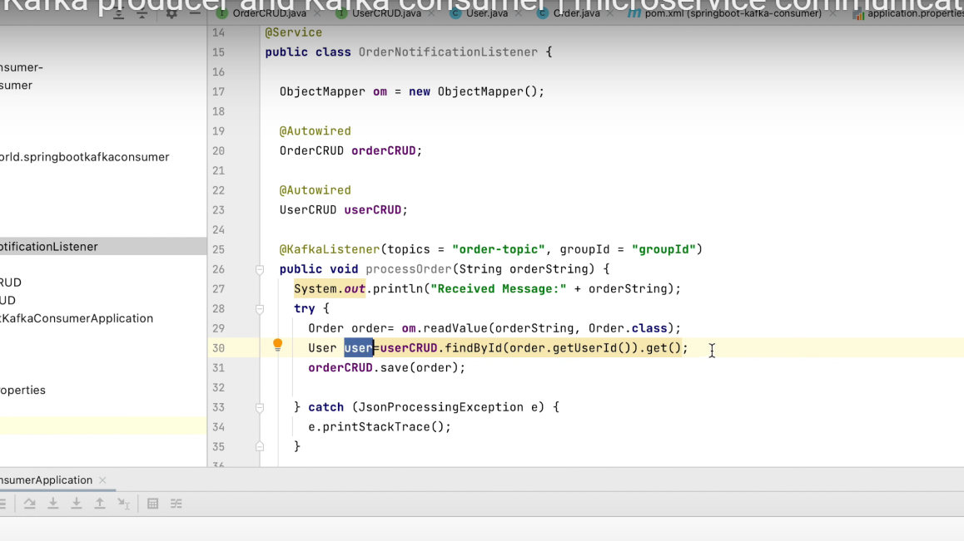

Now we will start both the services

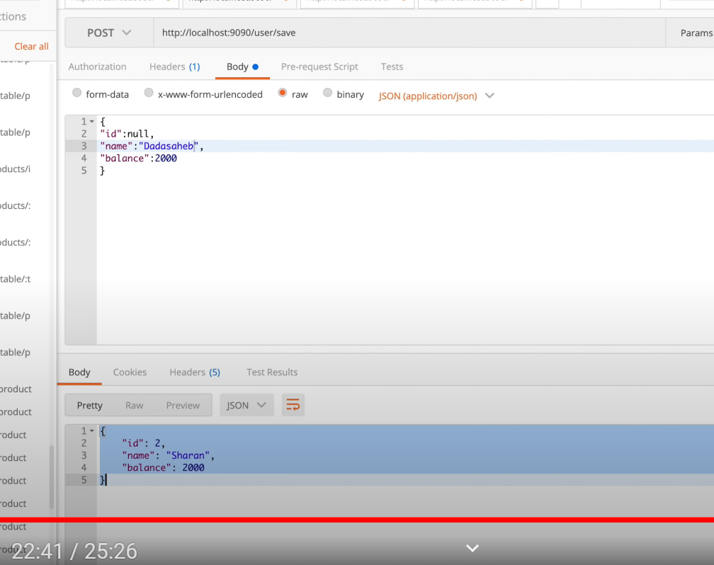

STEPS  **TO START AND WORK IN A KAFKA TOPIC**

**1.STARTING ZOOKEEPER SERVER**

.\bin\windows\zookeeper-server-start.bat .\config\zookeeper.properties

**2.Starting kafka server**

.\bin\windows\kafka-server-start.bat .\config\server.properties

**3.Create a topic**

.\bin\windows\kafka-topics.bat --create --topic quickstart-events --bootstrap-server localhost:9092

**4.Describe the topic**

.\bin\windows\kafka-topics.bat --describe --topic quickstart-events --bootstrap-server localhost:9092

**5.Write to topic**

.\bin\windows\kafka-console-producer.bat --topic quickstart-events --bootstrap-server localhost:9092

**6.Read from the topic**

.\bin\windows\kafka-console-consumer.bat --topic quickstart-events --from-beginning --bootstrap-server localhost:9092